**Model from paper, 5 epochs, minibatch 512, validation samples.**



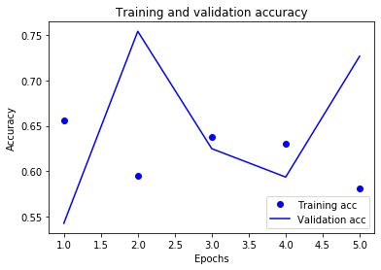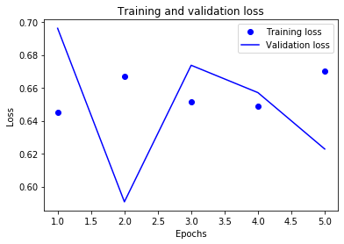

**Model from paper, 5 epochs, minibatch 512, validation samples.**



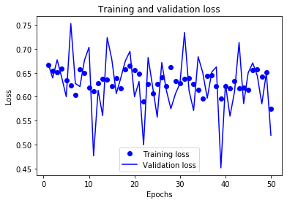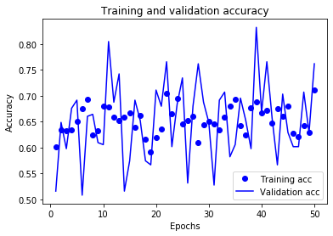

**Model from paper, 50 epochs, minibatch 512, Adam, No dropout.**



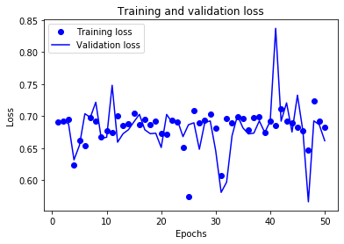 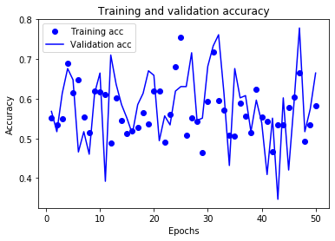

**OVERFITTING. Model from paper, 50 epochs, minibatch 512, Adam, No dropout.**

Trained with 200 samples the model overfits around 40 epochs.

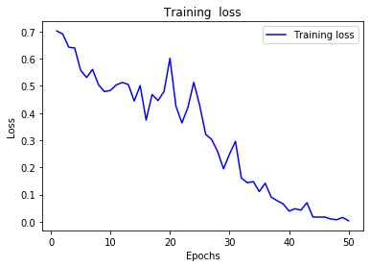 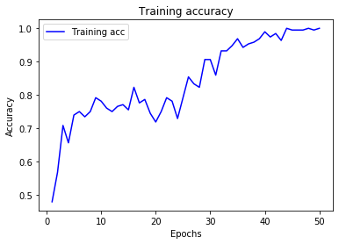

**OVERFITTING. Model from paper, 50 epochs, minibatch 512, Adam, No dropout.**

Trained with all the dataset but dropping the samples with scores between -3 and 3



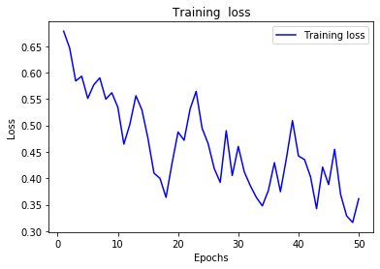 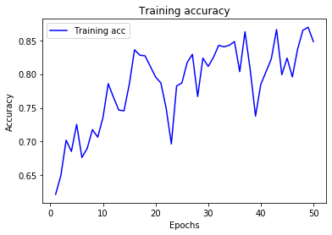

**Model from paper, Adam, batch_size = 55, dropout, validation samples**



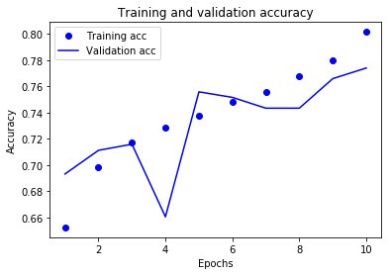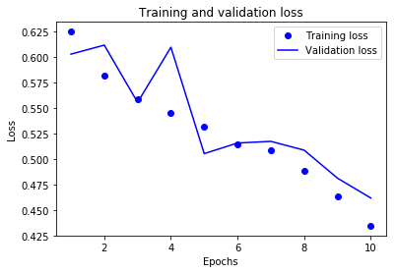

**Model from paper, Adam, batch_size = 55, dropout, 25 epochs,validation samples**

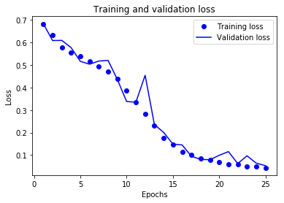

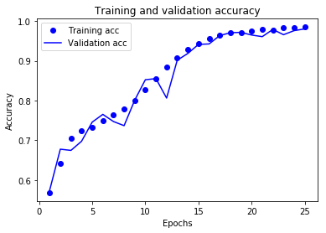

# Model paper, 25 epochs

**Results on train set**



**Results on validation set**

